Go To Slack Api Website

<https://api.slack.com/>

Sign Up or Log in to website

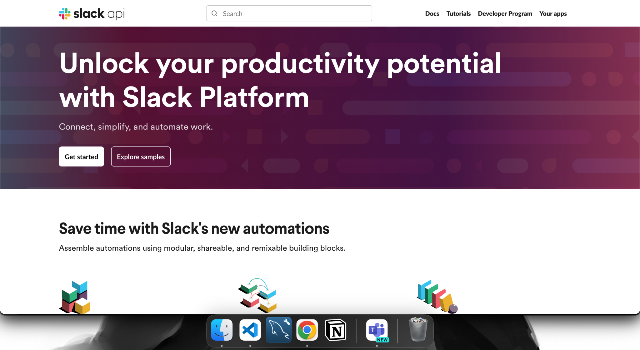

Click On Your Apps

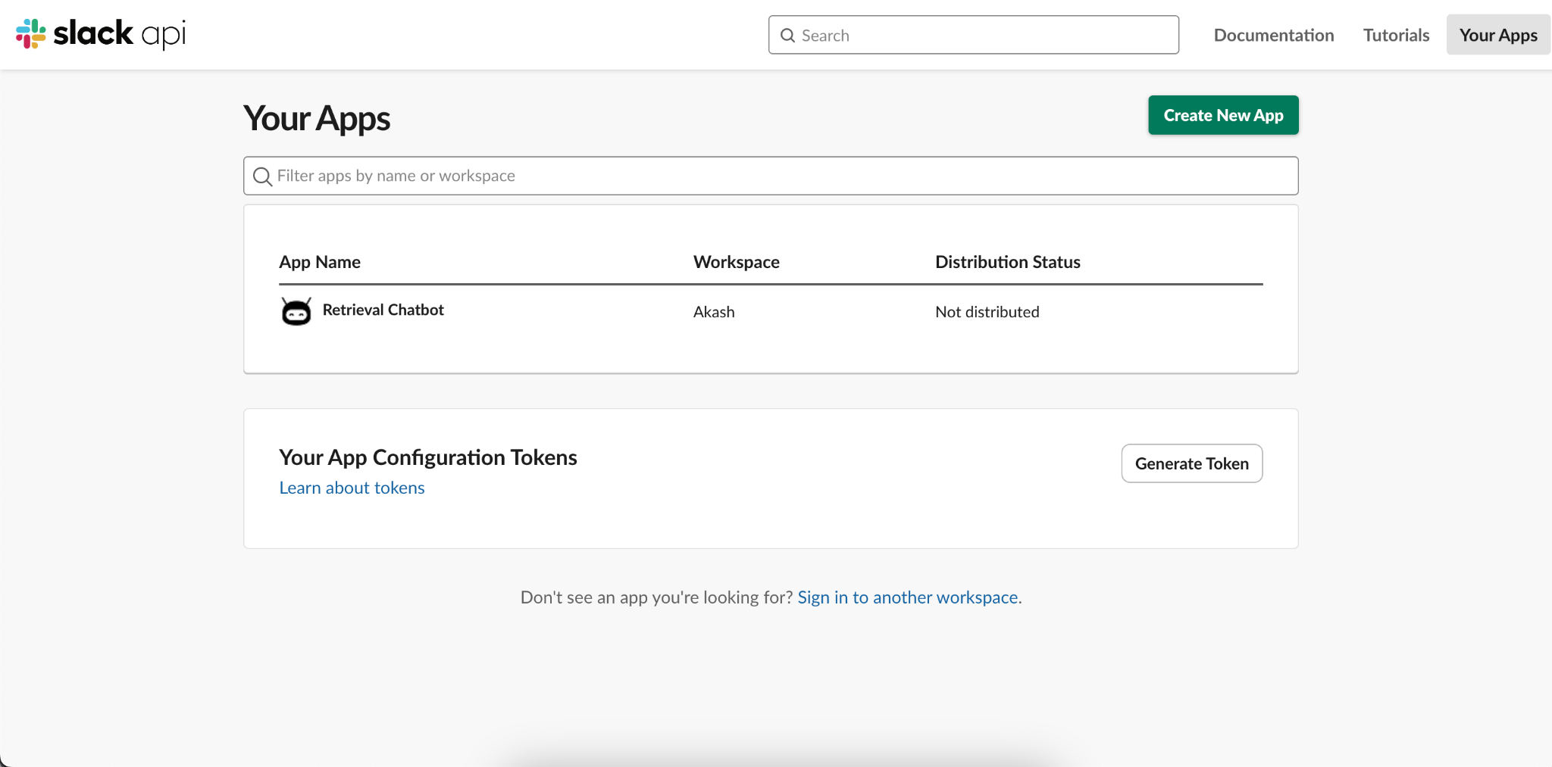

Click On Create New App

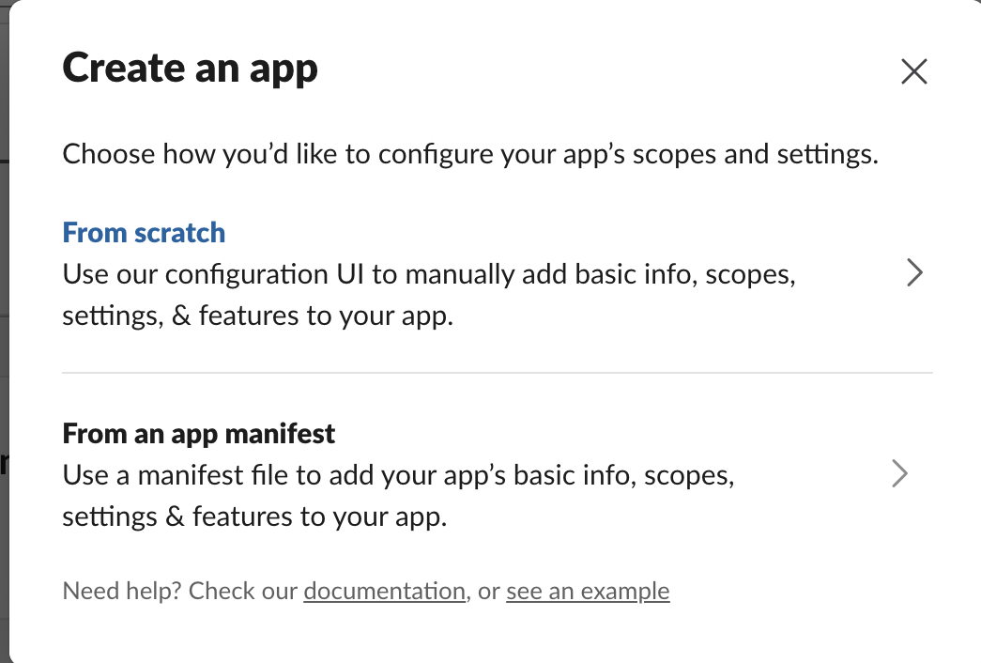

Select from Scratch

Add Bot_name and select the Workspace and click on create App

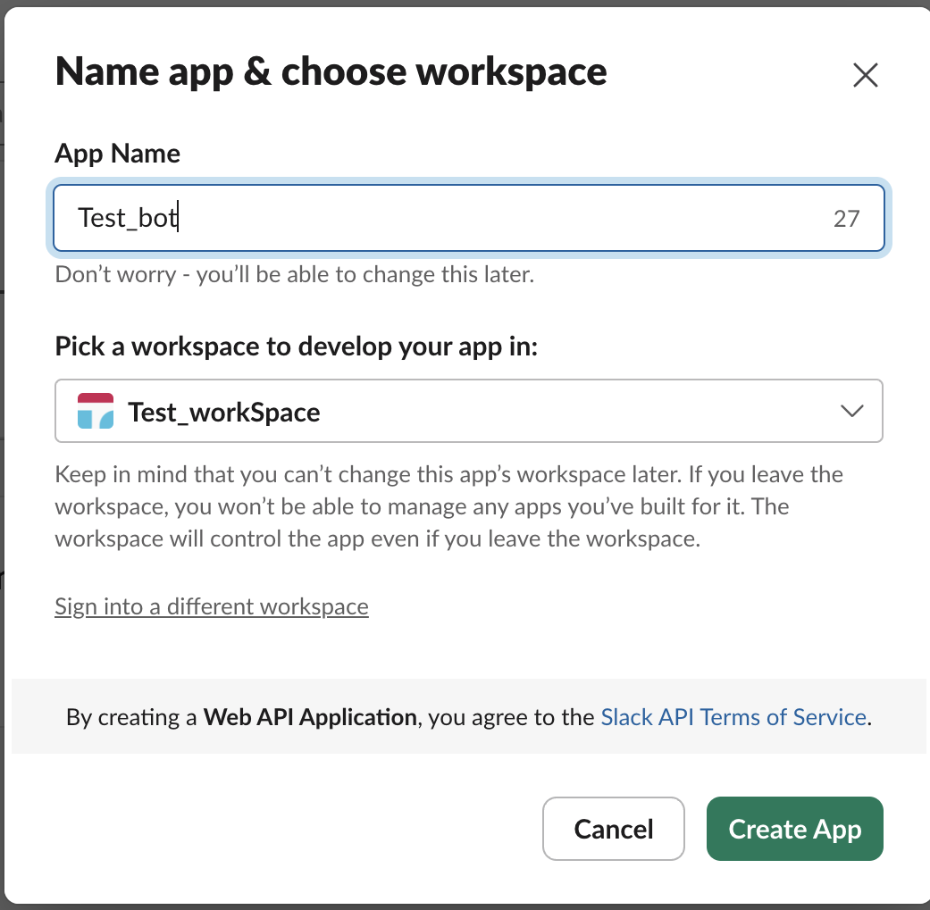

You got an interface like below where you can change all the settings of bot.

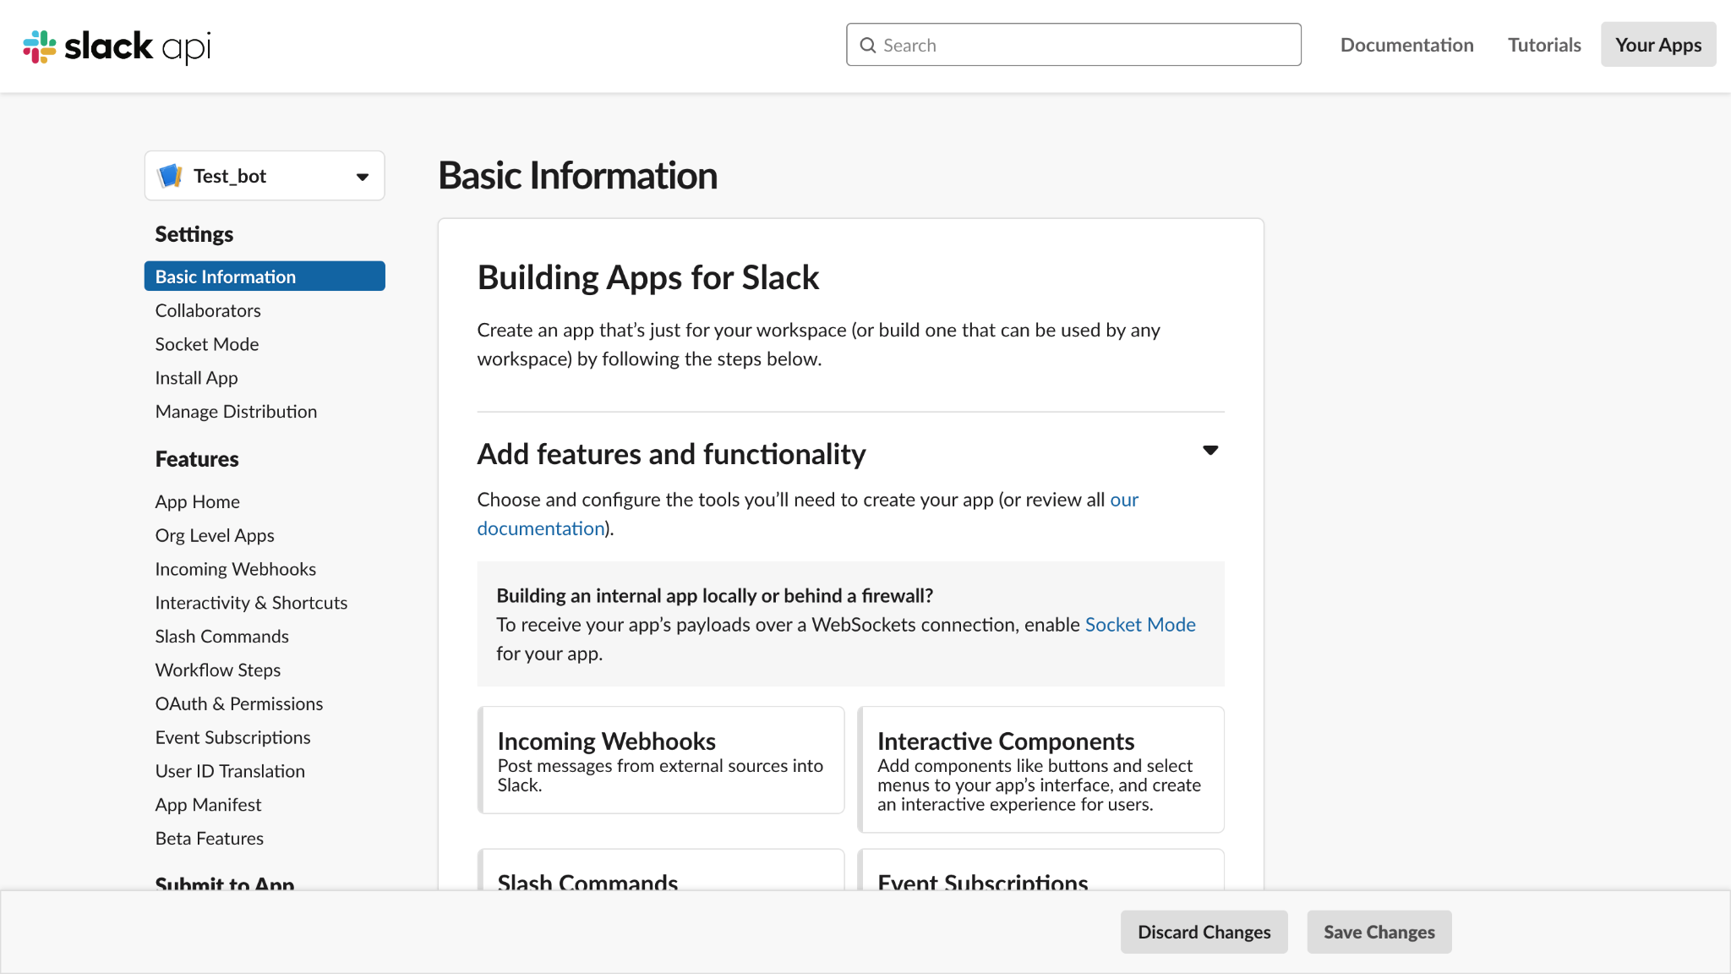

Click on OAuth & Permission

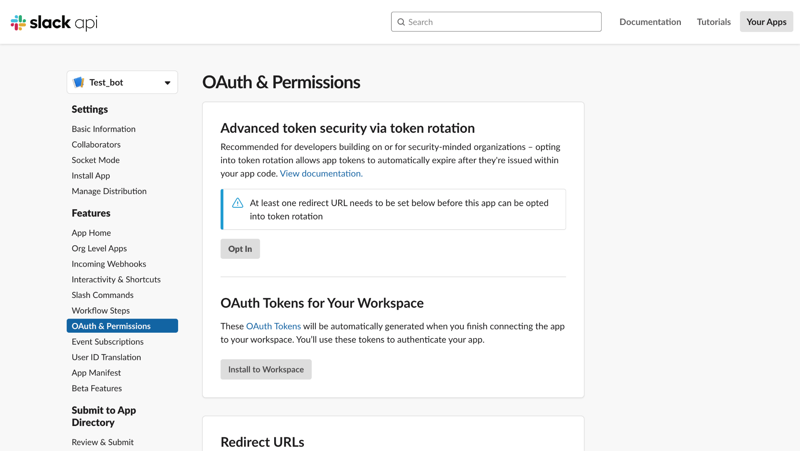

OAuth & Permission >> Scopes >> Bot Token Scope >> Add An OAuth Scope

Scroll down and Goto Scopes Section

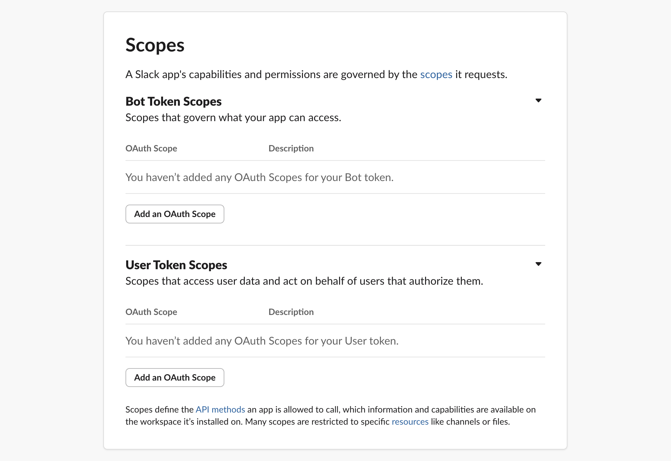

Add Scopes

Chat.write

chat:Write.public

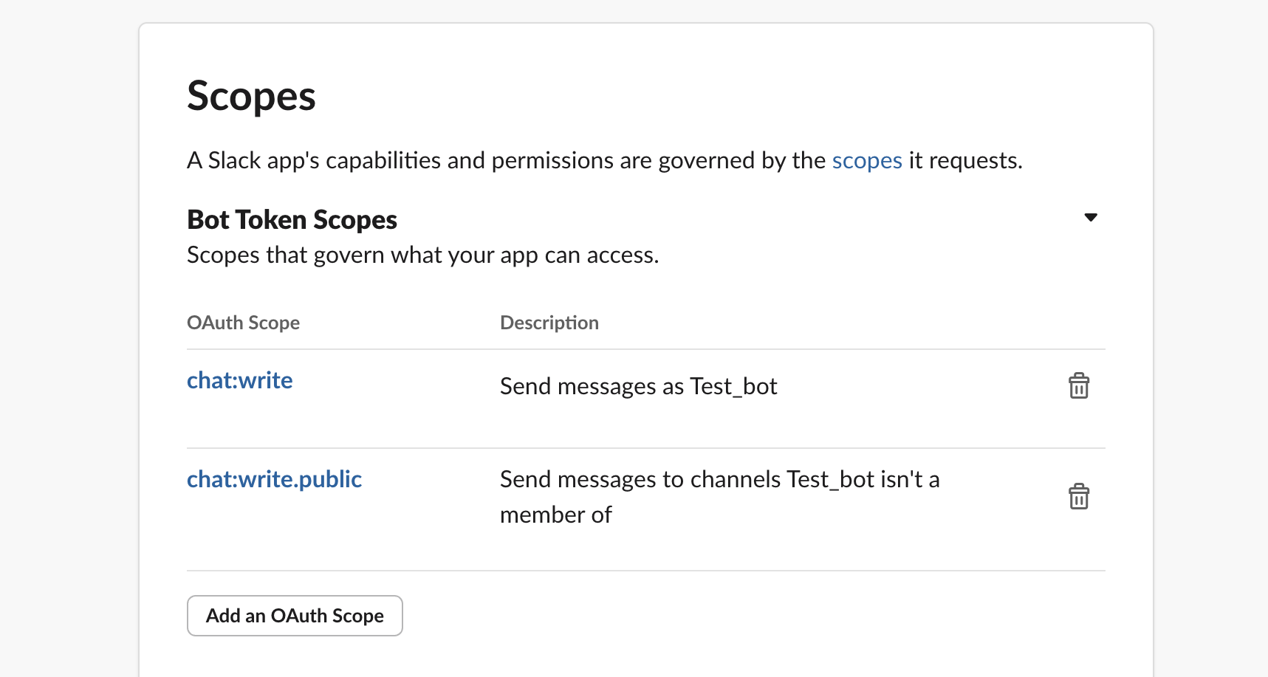

OAuth & Permissions >> OAuth Tokens for Your Workspace >> Install to Workspace

Click on Install to workspace >> Allow

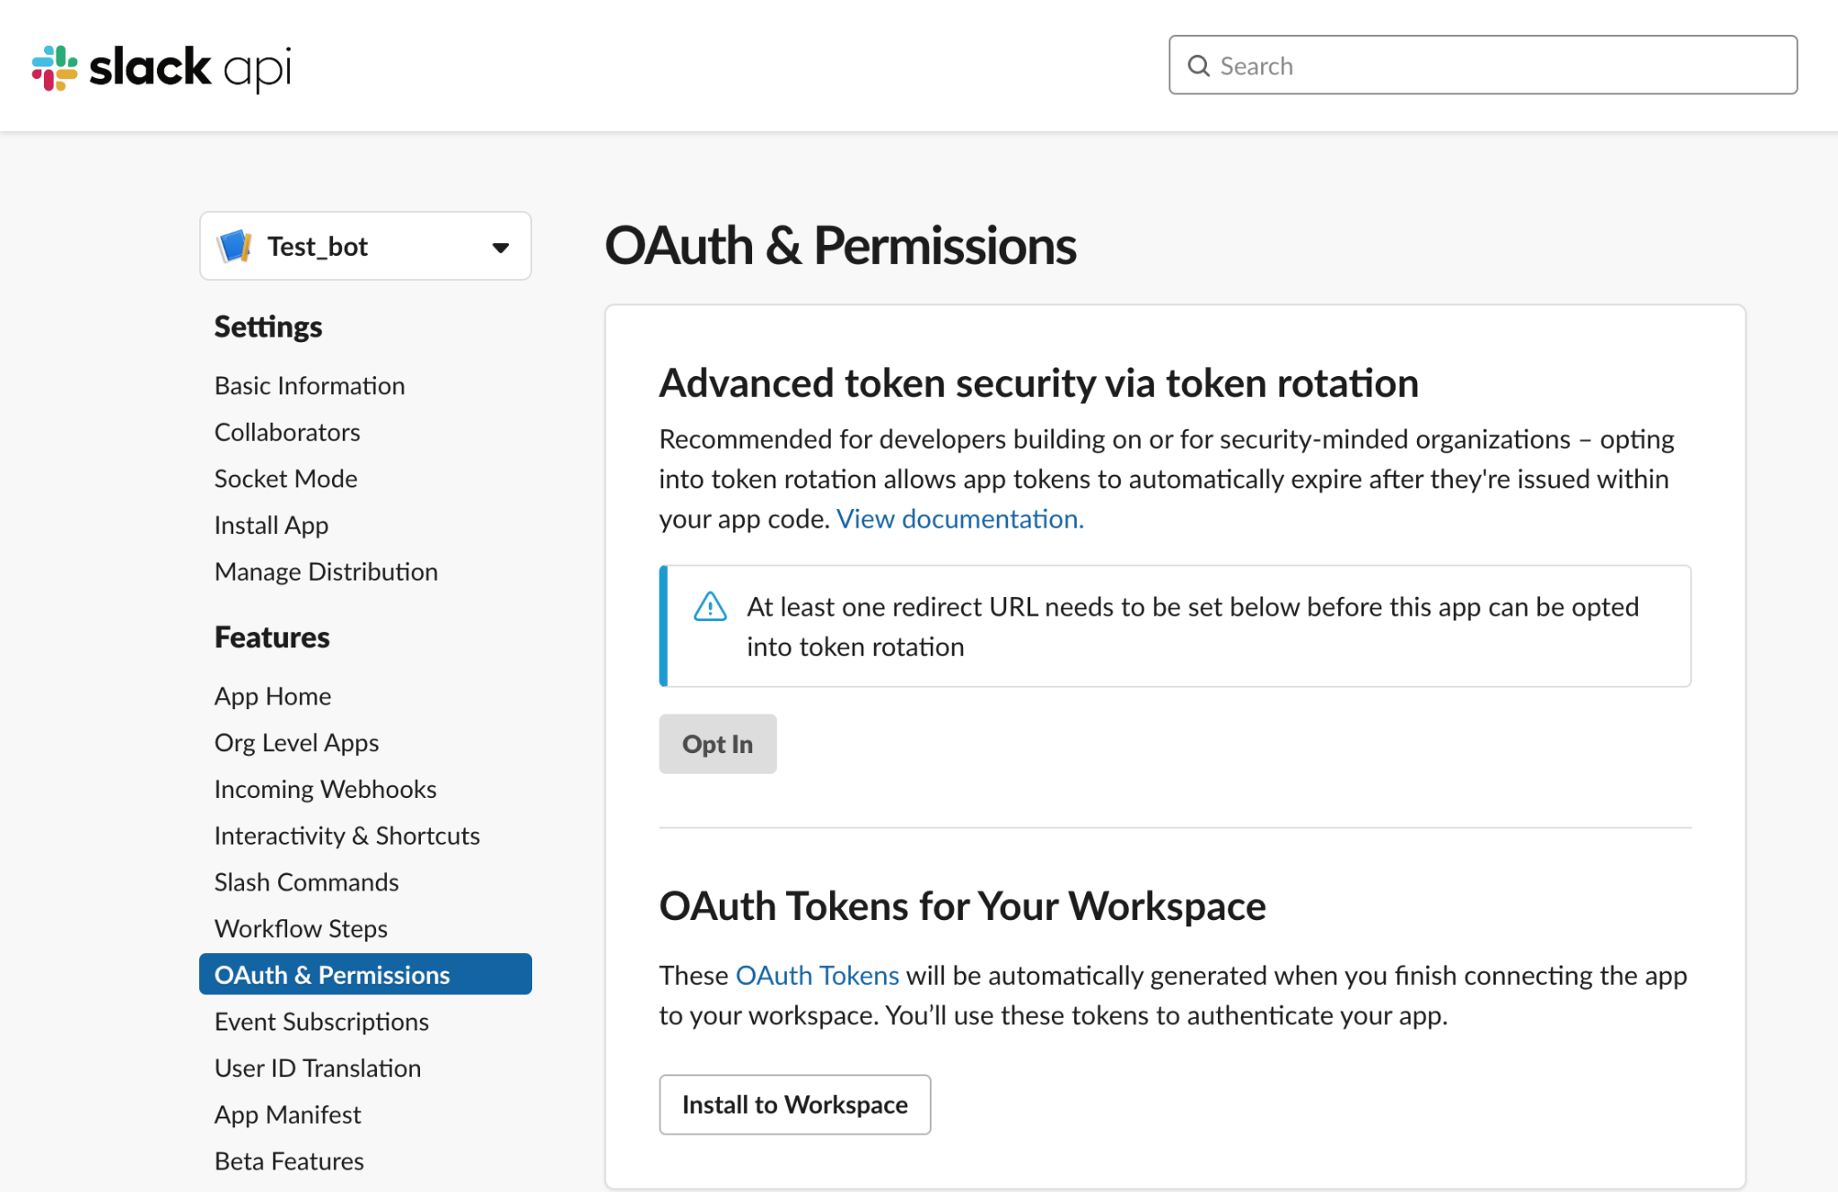

After that you got Bot User OAuth Token :

Copy That and save it somewhere we need it in the Code

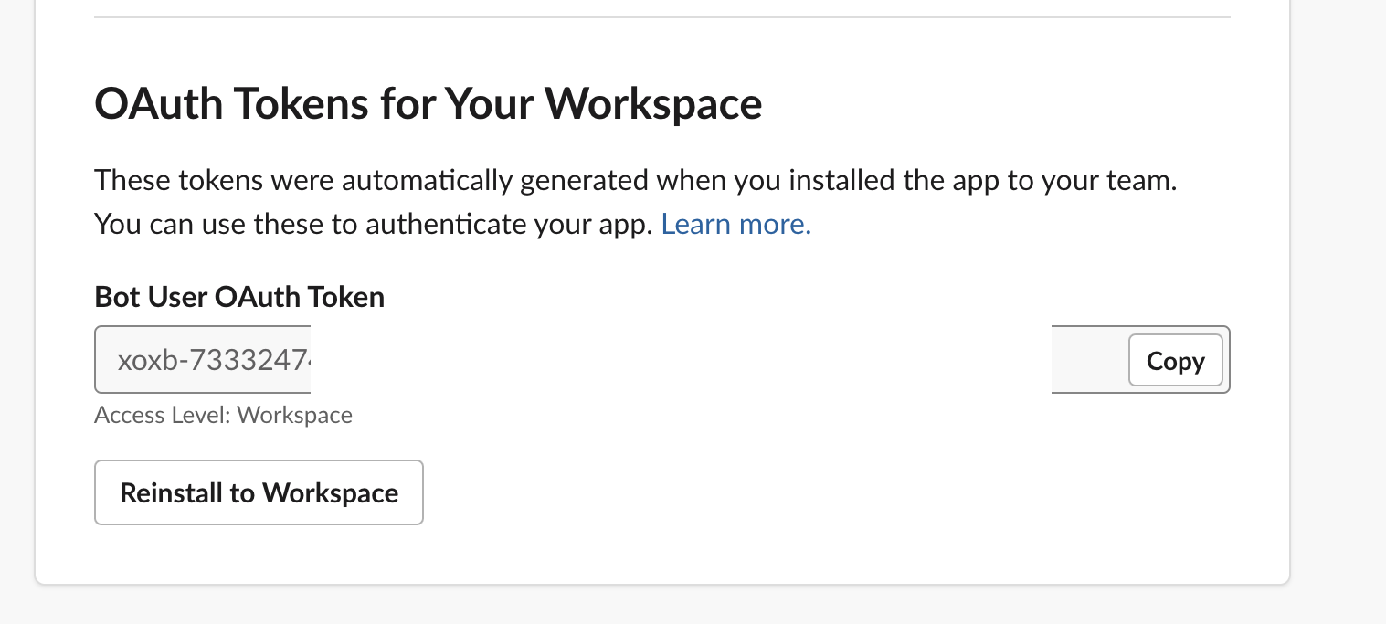

GoTo Basic Information

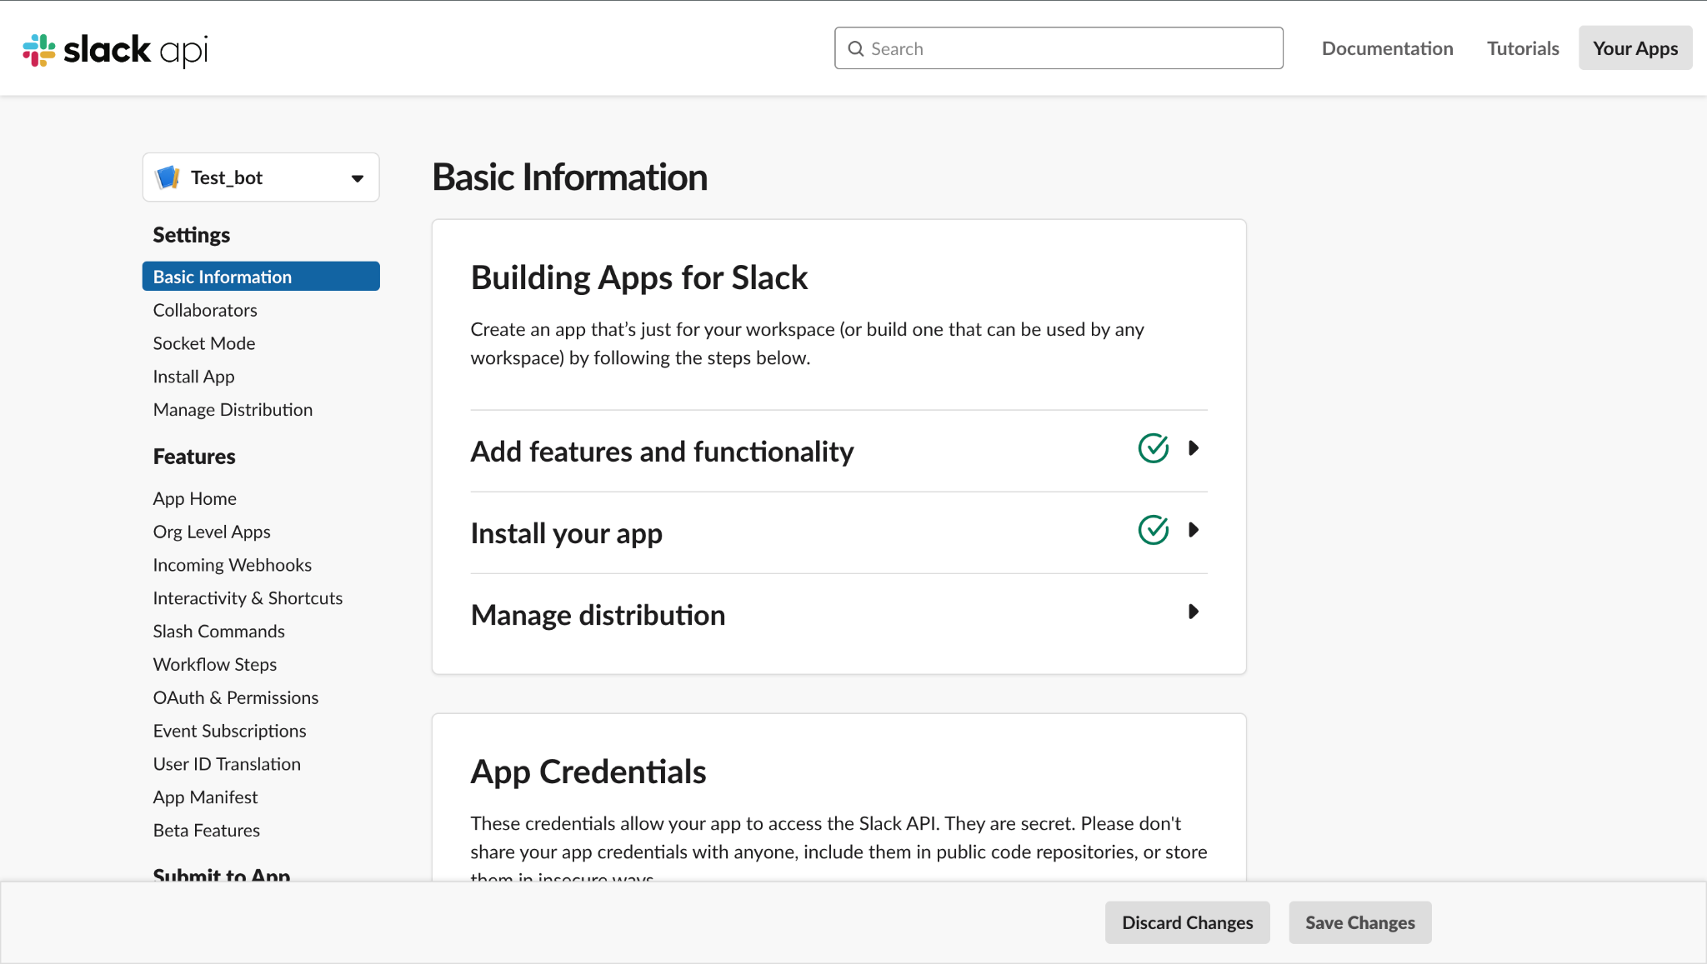

Basic Information >> App-Level Tokens >> Generate Token And Scopes

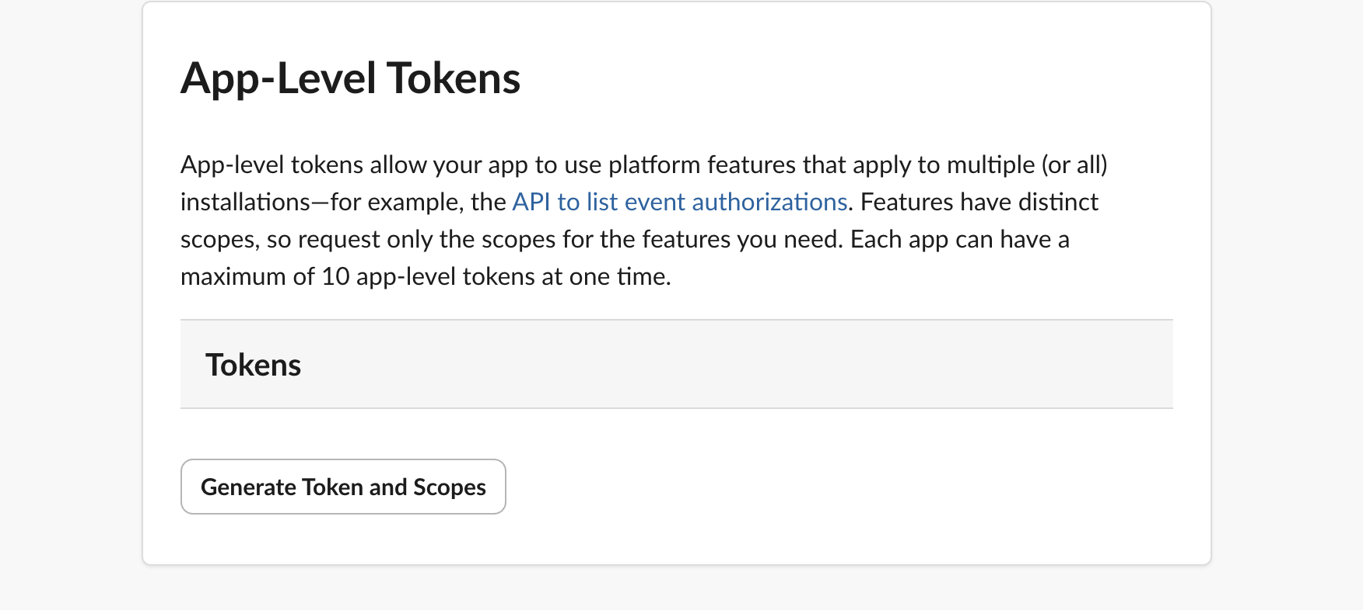

Add Token Name and Add Connection.write Scope as it added into the Scope Then Click on Generate

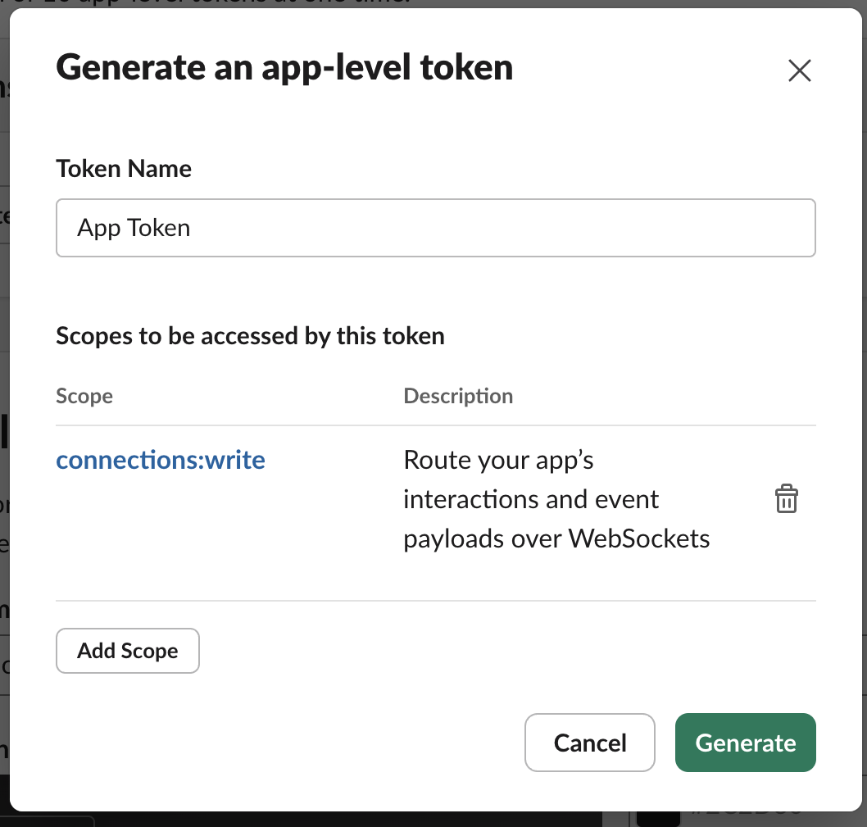

Another Token Is Generated copy It and save this App Token

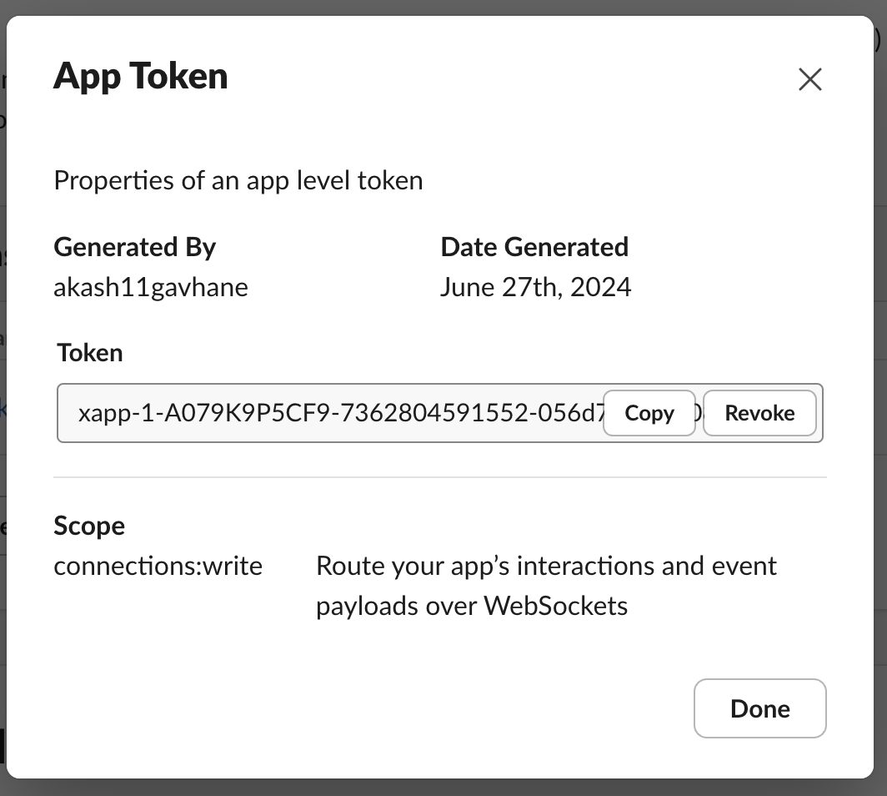

Go to Socket Mode >> Enable Socket Mode

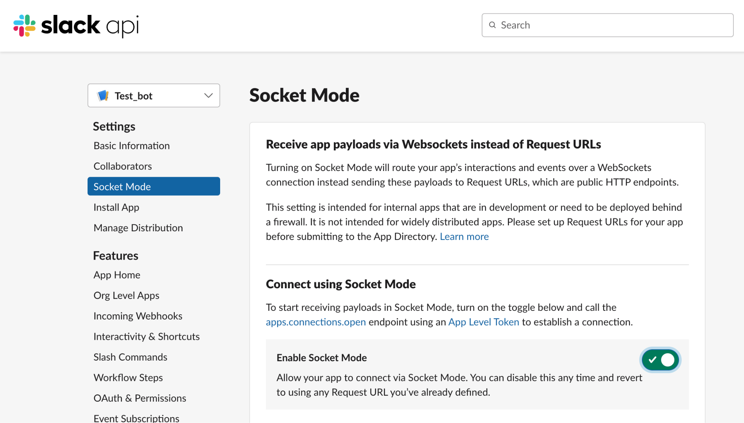

Goto Interactivity and Shortcuts >> Enable interactivity if it is Disabled

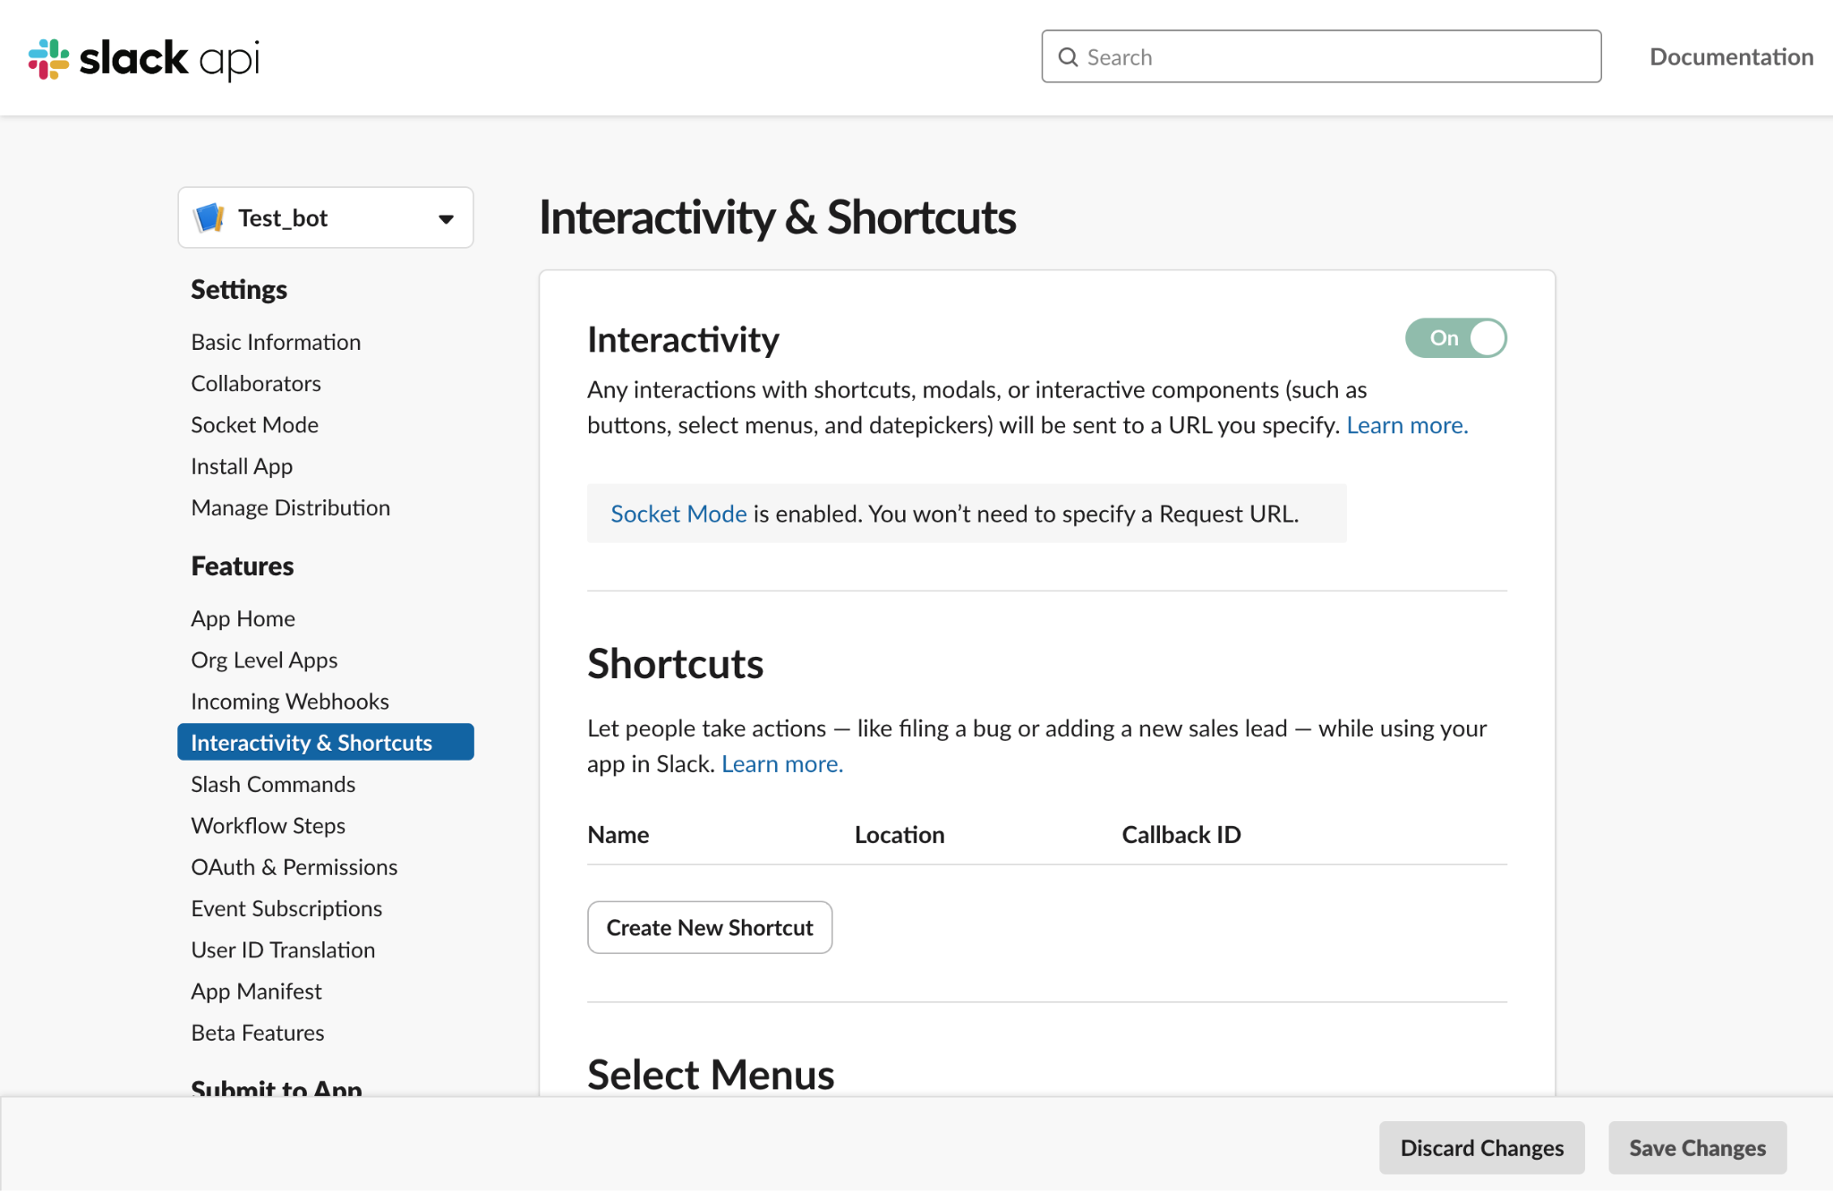

Then Goto Event Subscription >> Enable Event Subscription

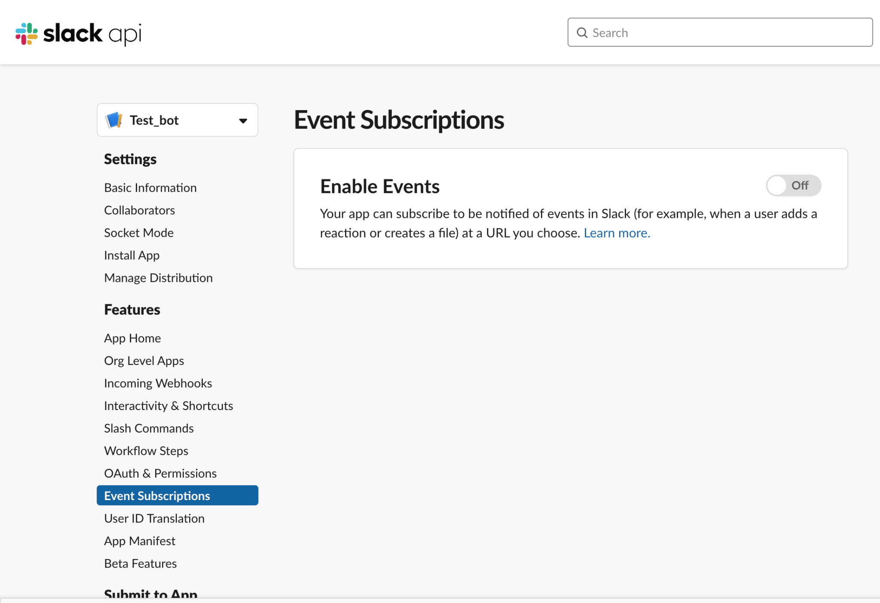

Event Subscription >> Enable Event Subscription >> Subscribe to bot Events >> Add bot User Event >> Add below Events >> Click on Save Changes

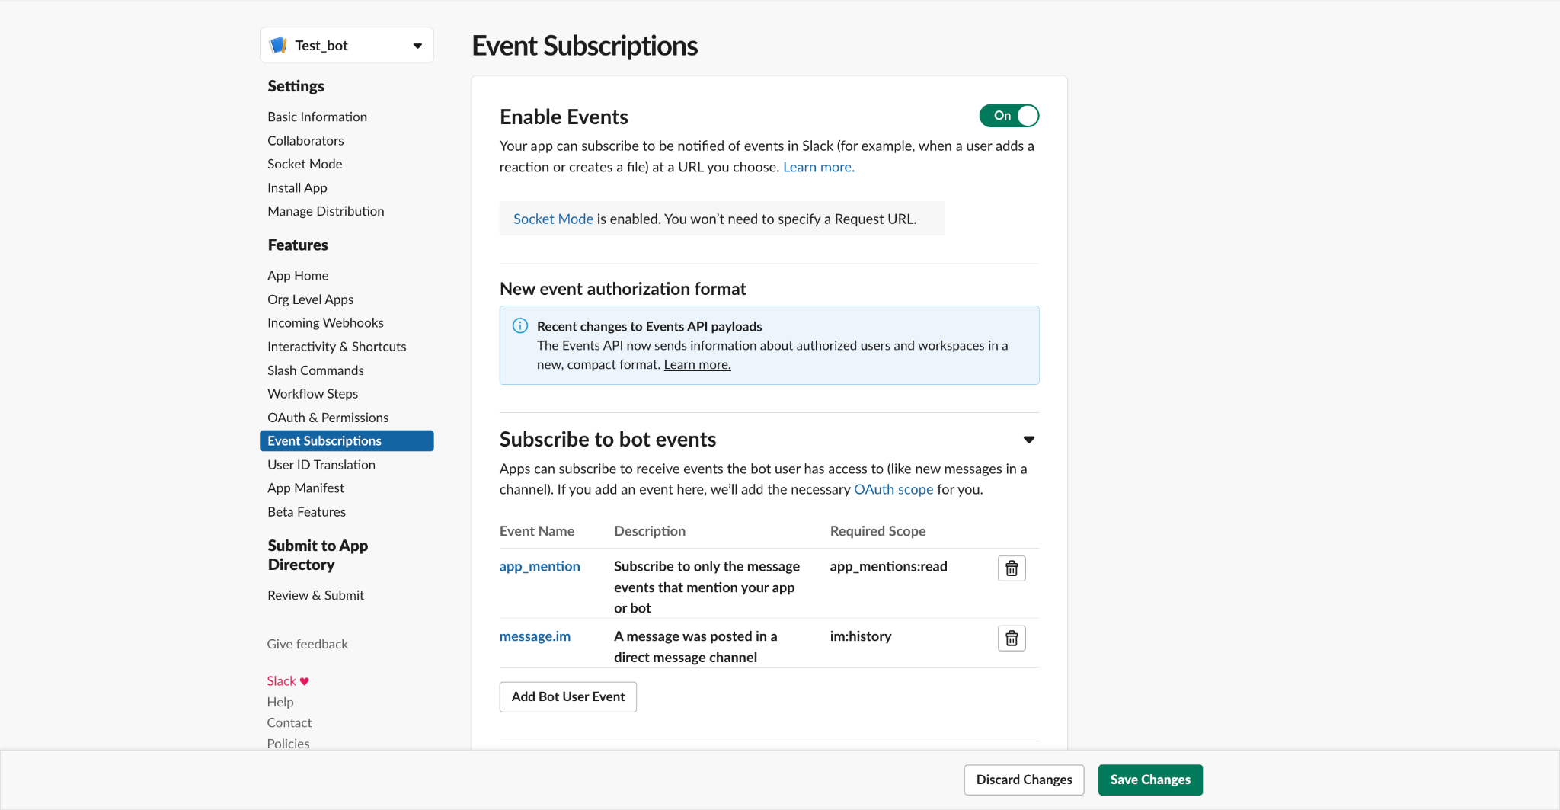

Click to reinstall your App >> allow

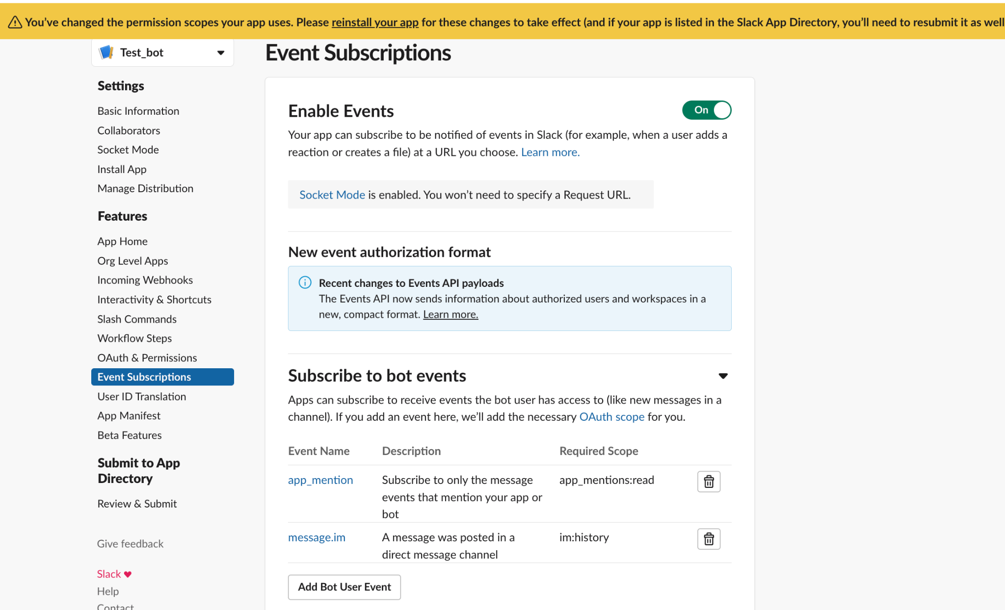

App Home >> Show Tabs >> click on allow users to send slash commands as below

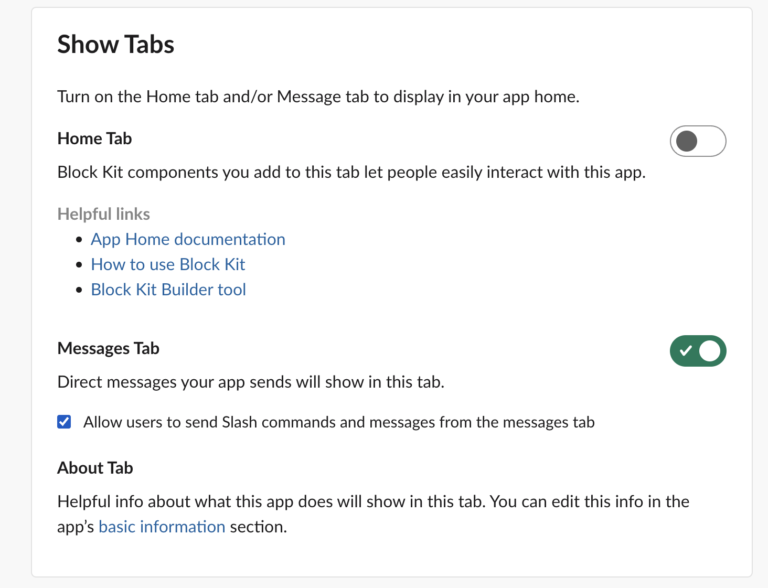

Now in Workspace we can able to see the Test_bot Interface (chat option)

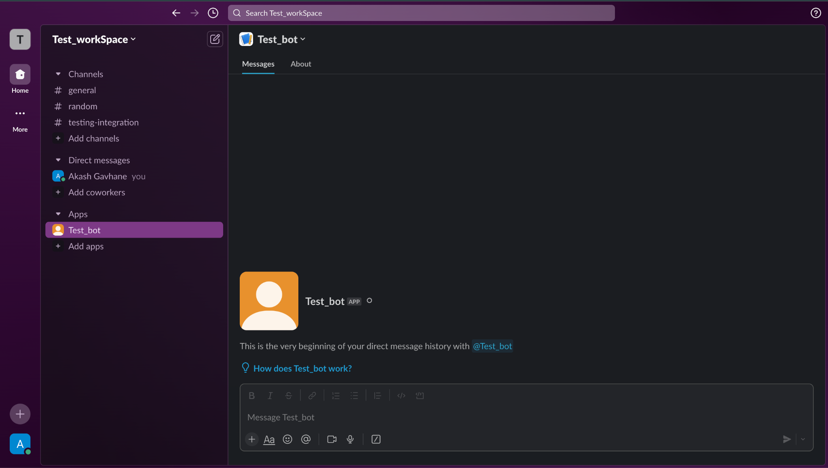

Code Part :

Install Libraries :

pip install slack_bolt

pip install langchain

Code :

app.py # main slack app

import os

from slack_bolt import App

from slack_bolt.adapter.socket_mode import SocketModeHandler

from dotenv import load_dotenv

import requests

# Load environment variables from .env file

load_dotenv('.env')

# Initializes your app with your bot token and socket mode handler

app = App(token=os.environ.get("BOT_USER_AUTH_TOKEN"))

# in base url change url and endpoint with bot url

base_url = "http://127.0.0.1:8000"

# change payload as per the bot input

def call_search_api(query: str):

payload = {"input": query}

response = requests.post(f"{base_url}/query", json=payload)

if response.status_code == 200:

return response.json().get("output")

else:

return f"Failed to call search API: {response.status_code}, {response.text}"

#Message handler for Slack

@app.message(".*")

def message_handler(message, say, logger):

print(message)

output = call_search_api(message['text'])

say(output)

print(output)

# Start your app

if __name__ == "__main__":

SocketModeHandler(app, os.environ["APP_TOKEN"]).start()

.env file -> put all keys in .env file

